**FPST 2023 – Exercise – Hazard Recognition and Control**

火车开在水上

|  |
| --- |
| **HAZARD OBSERVATION – Picture Number: 11** |
| Hazard Description:  A fall hazard behavior was observed at the bucket of the excavator.  An employee was exposed to an unguarded opening to a lower level of over 10ft, despite that there is water on the lower surface, without any fall protection system. Such behavior might result in severe injury or fatality as well as a contusion. |
| *Recommended Corrective Action (list the appropriate hierarchy of hazard control level):*  Safety training should be given to the employee before taking actual works. (Administrative Control)  Personal Protection Equipment like some falling protection system should be utilized on the bank. (PPE) |

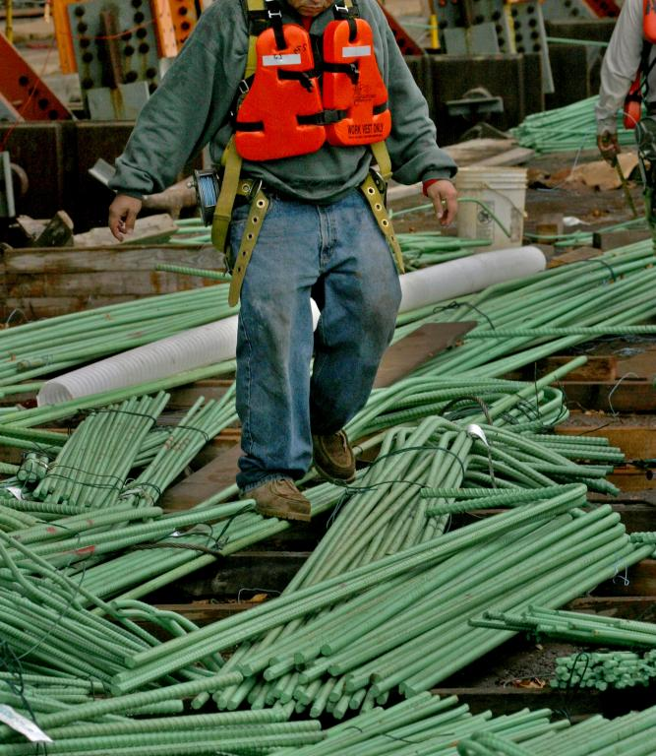

|  |
| --- |
| **HAZARD OBSERVATION – Picture Number: 12** |
| Hazard Description:  A physical hazard behavior is observed in case the employee can hardly keep balance on the thin pipes.  An employee was exposed to the potential to slip because the surface of the thin pipe is too narrow and smooth. Such unsafe behavior could cause severe injury to the employee. |
| *Recommended Corrective Action (list the appropriate hierarchy of hazard control level):*  Tidy up the workplace by removing all kinds of pipes, wires, and so forth to ensure a plain and clear walking environment. (Elimination) |

|  |
| --- |
| **HAZARD OBSERVATION – Picture Number: 13** |
| Hazard Description:  A mechanical hazard condition is observed on the rotating machine with apparent corrosion as well as some traces of aging.  The machine might need urgent maintenance as well as some cleaning, otherwise, it could probably function wrongly and bring hazards to the employee. |
| *Recommended Corrective Action (list the appropriate hierarchy of hazard control level):*  A cover should be equipped so that there is no bared gear or mechanical equipment. (Engineering Control)  Regular maintenance and cleaning should be taken by the corresponding personnel. (Administrative Control) |

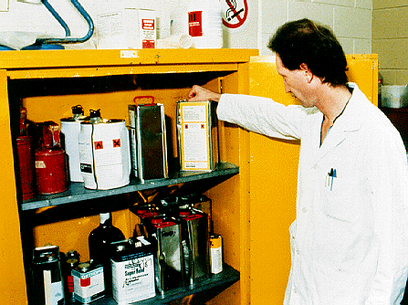

|  |
| --- |
| **HAZARD OBSERVATION – Picture Number: 14** |
| Hazard Description:  A chemical hazard condition can be observed in this cabinet with a number of flammable chemical containers.  The employee was exposed to the dangerous chemicals without any personal protection equipment which is required by OSHA. Not only the possibility of igniting the chemicals is increasing, but such unsafe behavior also put the employee at risk, especially for the part which is not covered by the clothes like the hand, the neck as well as the face. |
| *Recommended Corrective Action (list the appropriate hierarchy of hazard control level):*  Protective equipment like gloves or glasses should be utilized. (PPE)  Danger chemicals should be placed regularly in order in case they could be easily assessed. (Substitution) |

|  |
| --- |
| **HAZARD OBSERVATION – Picture Number: 15** |
| Hazard Description:  A chemical hazard condition is observed in a table where lots of cleaning supplies are placed together.  Cleaning supplies with different chemical components are placed together results in the potential hazard that they might mix together by accident and intriguing more severe reaction. Moreover, people might also overturn these containers by chance, which might lead to some unexpected results. What is more, the mixture of ammonia and Clorox might lead to the generation of chloramine gas, which is harmful to the respiratory system. |
| *Recommended Corrective Action (list the appropriate hierarchy of hazard control level):*  The cabinet contains specific types of chemicals that should be used to prevent the mix of different cleaning supplies. (Elimination) |